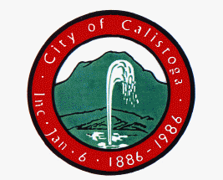

INVITATION TO ATTEND
SPHERE OF INFLUENCE
&
DETACHED ANNEXATION
INFORMATION MEETING

The public is invited to an informational meeting on potential revisions to the City of Calistoga’s Sphere of Influence needed to serve planned public facility and service needs, and a proposal on processing Detached Annexations for the Kimball Reservoir and Feige Canyon Tank Site. At this meeting, the public will have the opportunity to ask questions and comment on the Planning Commission Staff Report prepared for this issue.
May 22, 2008
5:30 – 7:00 pm
Community Center
1307 Washington Street
Calistoga, CA

Please note that Planning Commission discussion on this issue will resume at their May 28, 2008 meeting at 5:30 pm.
Questions? Please call:
Planning and Building Department
(707) 942-2827

